**Site:**  
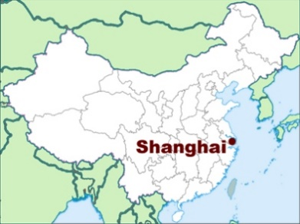Shanghai developed on a flat, low, plain on the banks of the Yangtze River. Shanghai is also located at the union of the Huangpu and Suzhou Rivers, so trading is very efficient in Shanghai.

**Population growth:**

In 1978, between 150 million and 200 million have migrated from rural to urban areal. China has over 100 millionare cities (over a million residents). In 2005, and in 2015 it has more than 17 million pepole. There were also 13 million workers in the city in 2005.

**Economic change(growth):**

Between 1949 and 1976, political influences focused attention away from rural areas, foreign influence and capitalist development.

In 1984 Shanghai was declared open to foreign deveopment. For 20 years, its ecenomic growth rate was over 12% per annum. By 1990 a new CBD was created, and by 2000 over 3000 skyscrapers were built.

**Housing and demographic issues:**

|  |  |
| --- | --- |
| **Issues** | **Possible solutions** |
| Overcrowding/housing | Medical care and family planning to control fertility levels |
| Water/air pollution | Organic waste used as fertilizer/Upgrading city transport system; limit car owners. |
| Transport | To improve safety, authorities build tunnels and bridges like under the Huangpu River. |

**Shanghai master plan:**

In 2000 Shanghai introduced the plan to develop three satellite cities to reduce congestion in central Shanghai.

Dongtan was a new city planned to produce zero waste and to use energy from renewable sources such as wind and solar. Grasses will be planted on rooftops and rain will be harvested. The city was planned to be car free and just cycling and walking is allowed.

There are many advantages of the city Dongtan, some are:

* Housing is affordable
* Waste is treated, landfills are allowed, and sewage is processed for composting.
* Renewable energy

However, there are also some problems in Dongtan:

* There is a lot of conflicts over water resources
* The natural areas of freshwater marshes will experience pressures for development